Create a new file and enter the string you want to encrypt

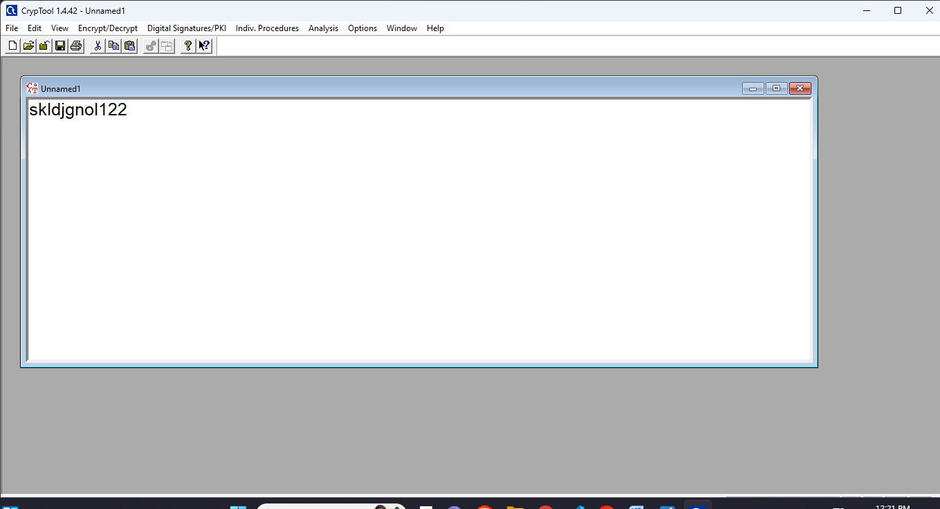

Select the Encryption/Decryption algorithm

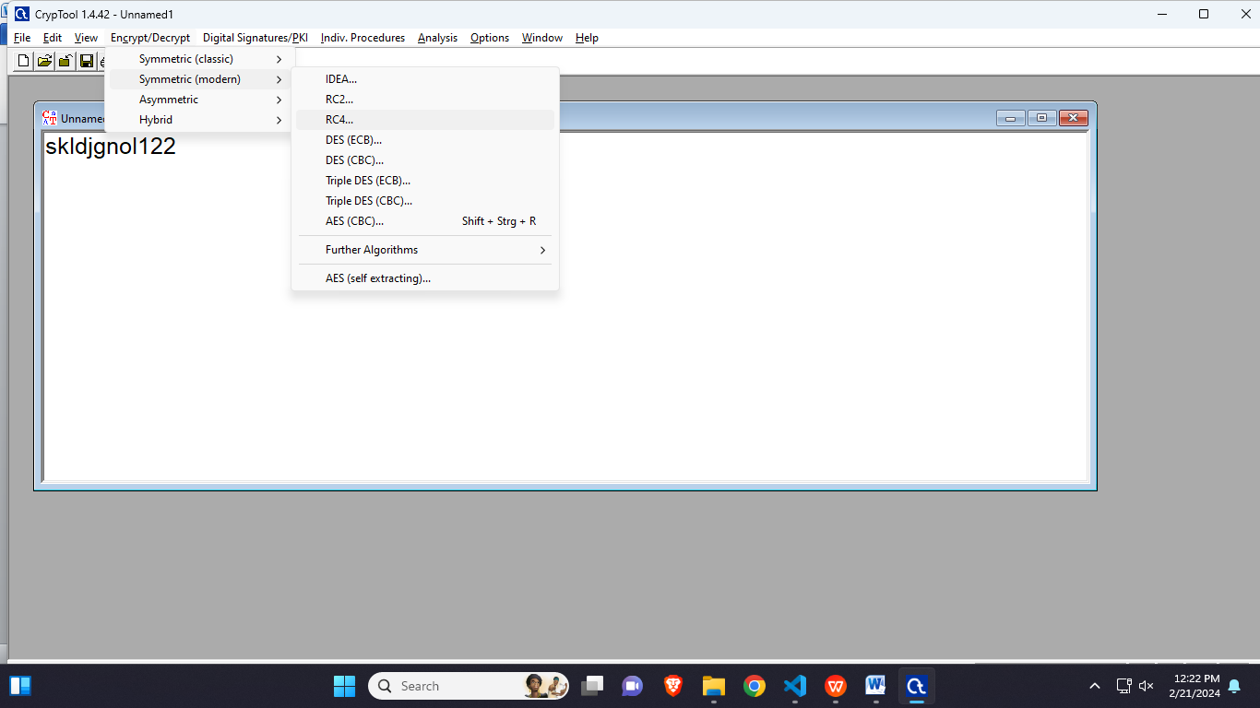

Enter key length

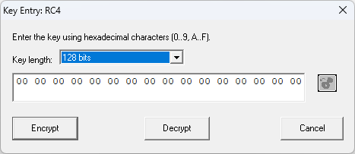

Your text will be encrypted

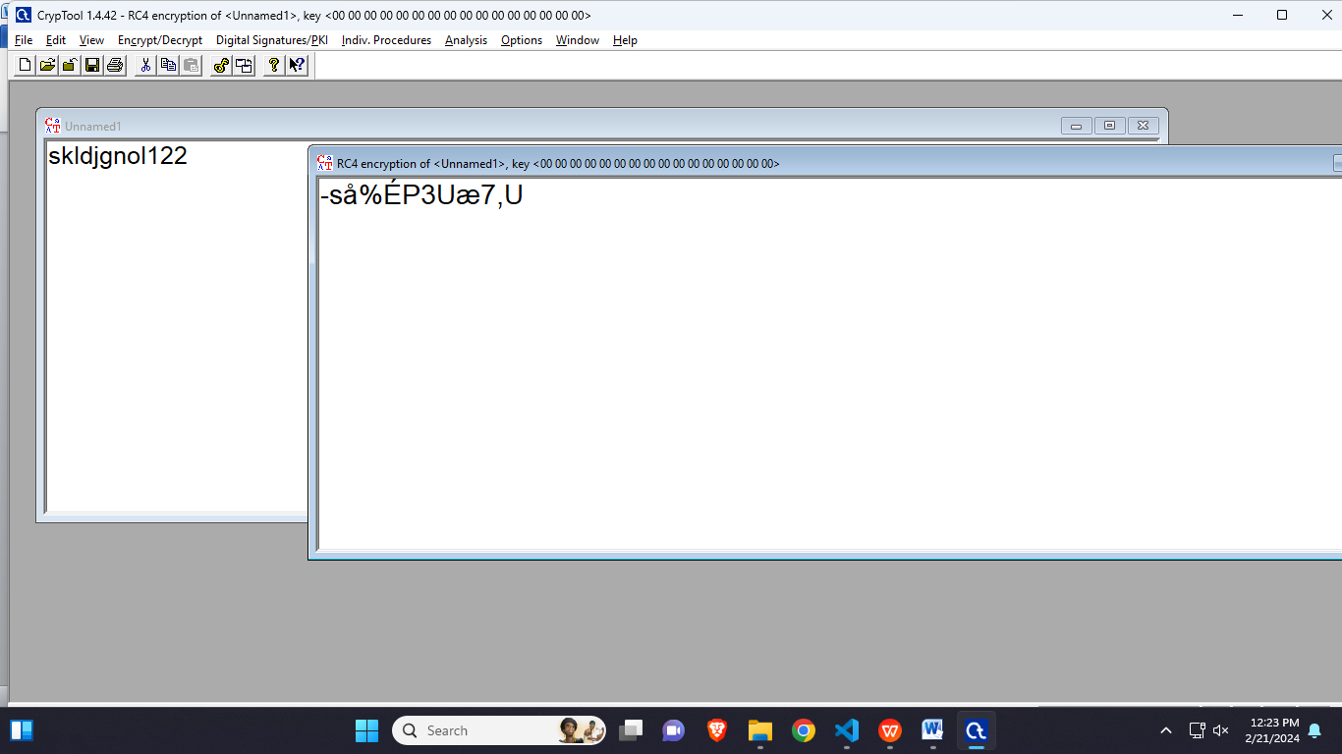

Now select the encrypted text and repeat same process to decrypt

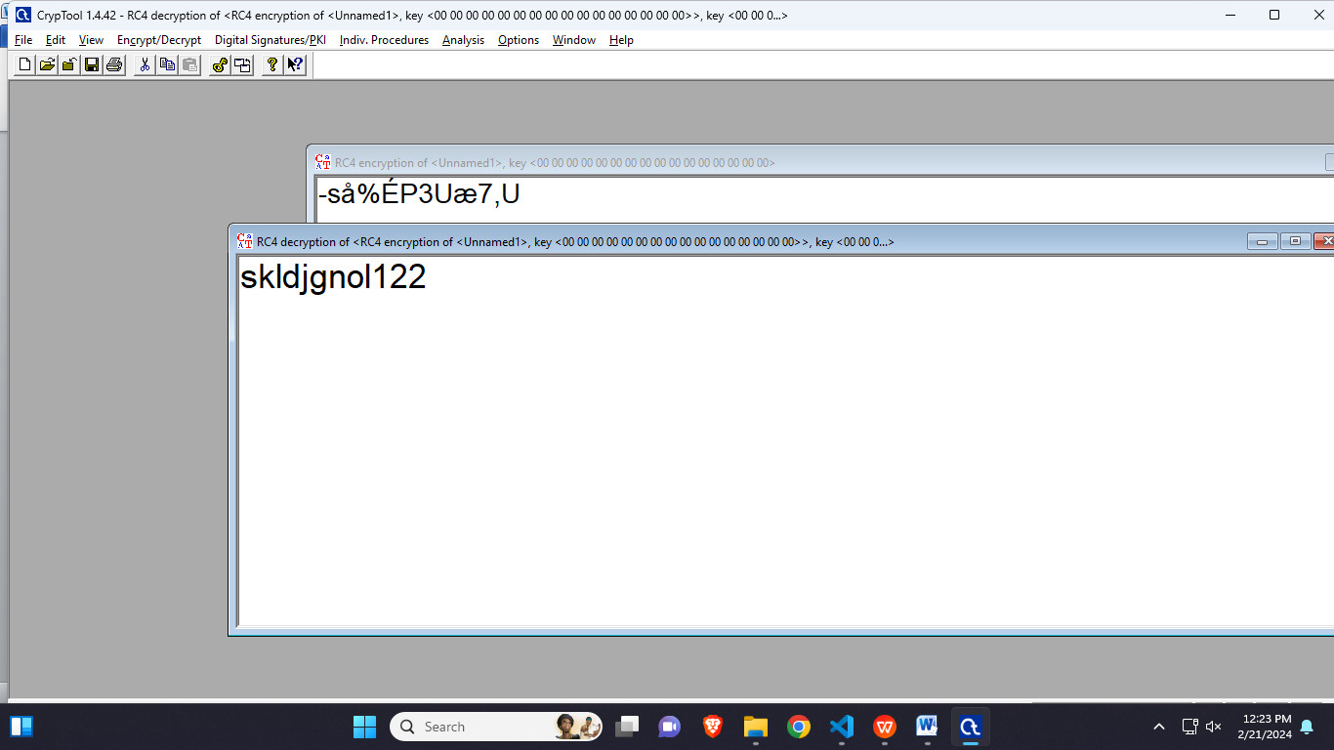

**Performing a dictionary attack:**

Select Cracker and select LM & NTLM Hashes

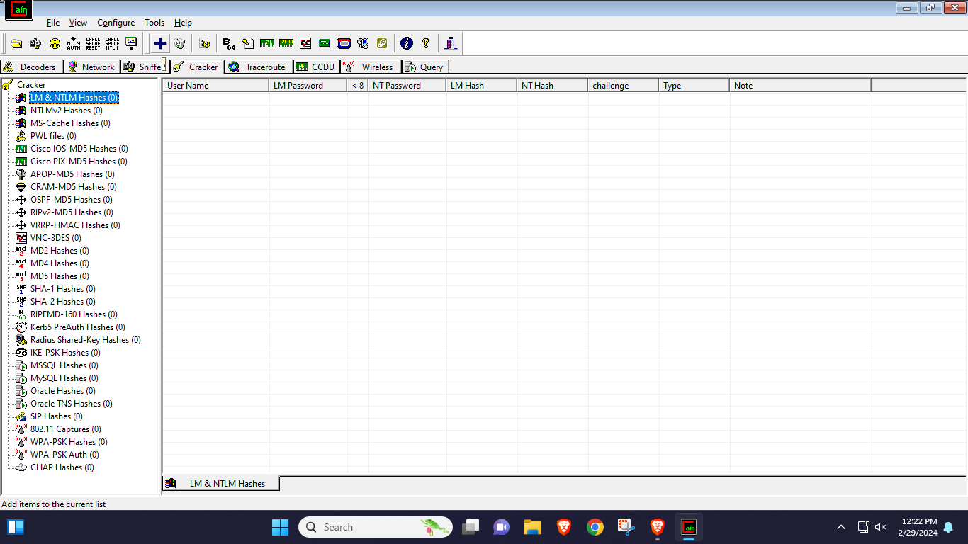

Import hashes from local system

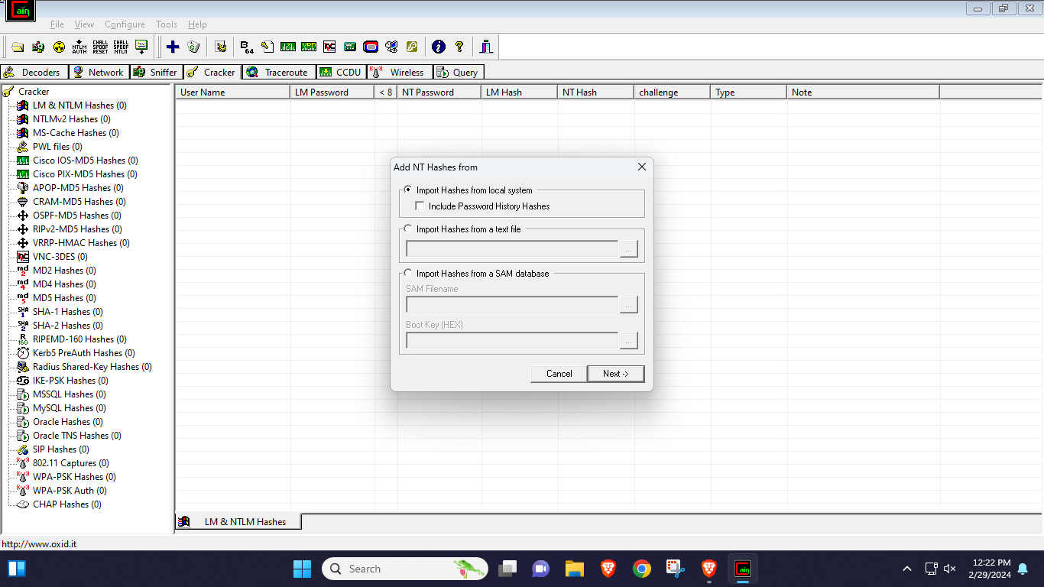

Select user, right click and select dictionary attack

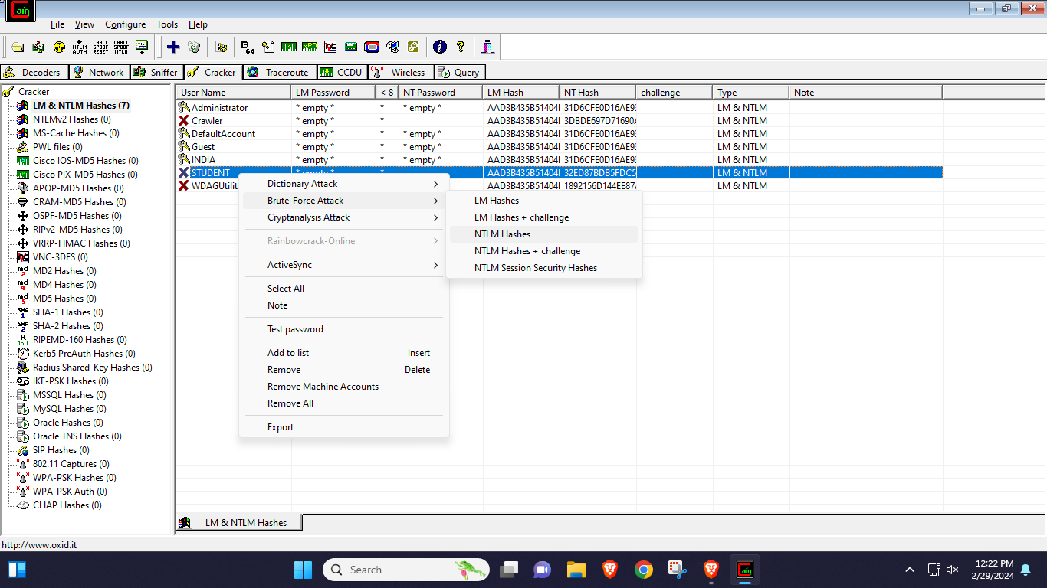

Browse and select text file(Dictionary)

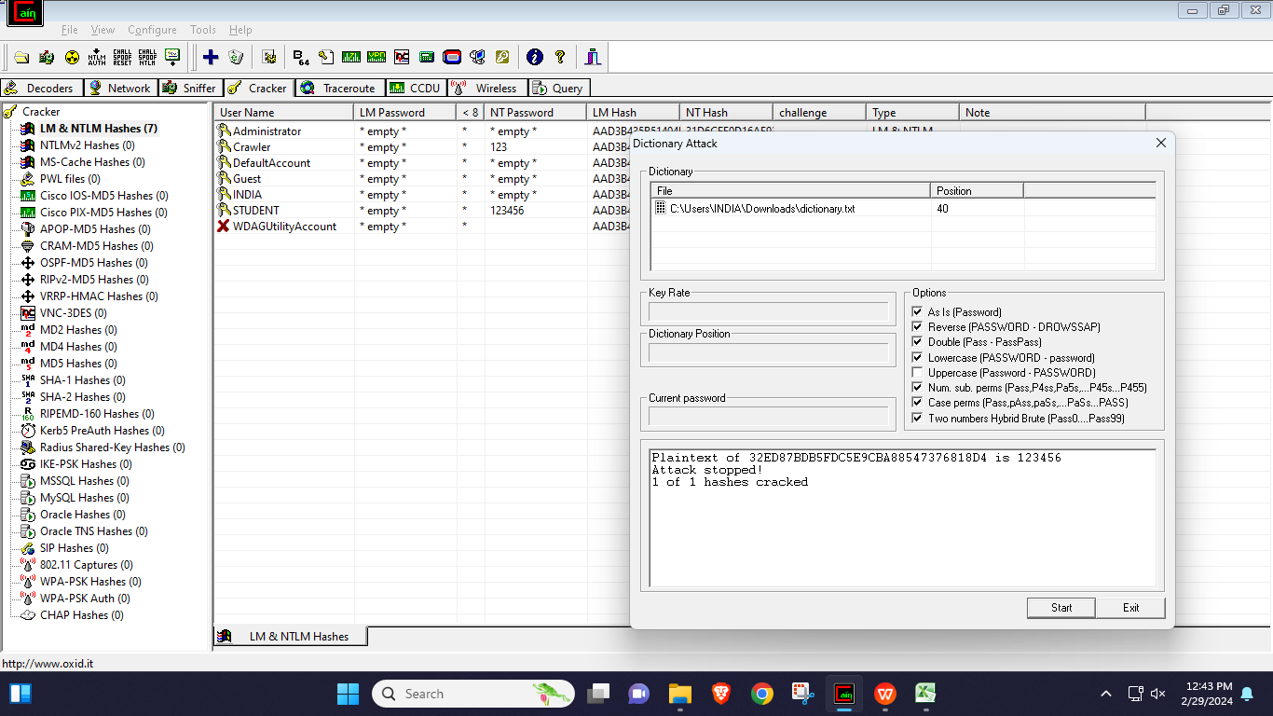

Click start and perform dictionary attack

